SELECT ORDER

The select order dialog, accessed from the main program screen via the Order Button.

By default, orders are selected by line and part type. By omitting the line name all parts of a part type are selected. A sort by drop down becomes enabled when the assembly line is blank.

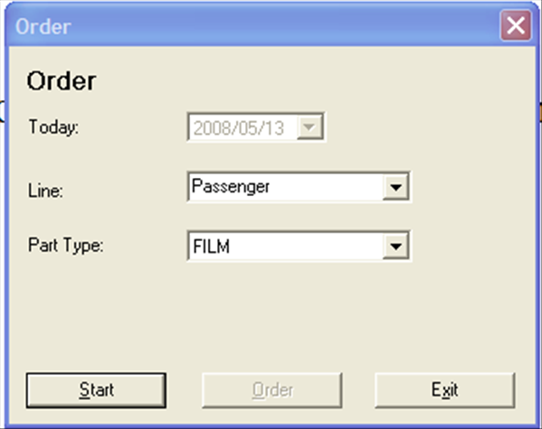

Options for the default screen:

- Today – Lists the current date, which is the order date. (No selection allowed)
- Line – Assembly line to order parts
- Part – Type of part to order. The default part types are file, valves, tires and wheels.
- Start – Build excel order screen from options.
- Order – Create orders from excel sheet data. (Enabled after order sheet is built)
- Exit – Cancel activity.
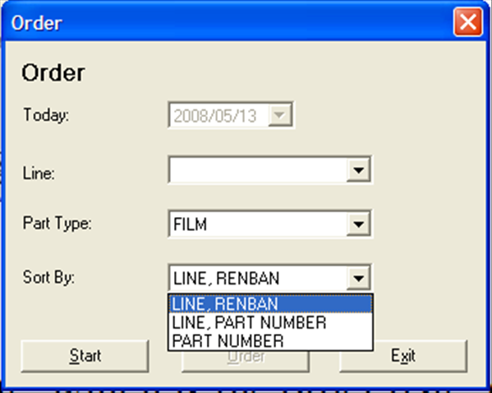

Added options for blank assembly line:

- Sort By – Sort part type by selected sort by option. All select parts are first sorted by size name to create the correct size and sharing pairs.

